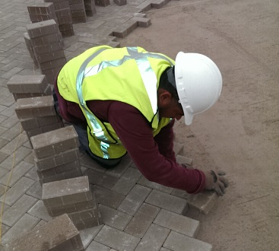

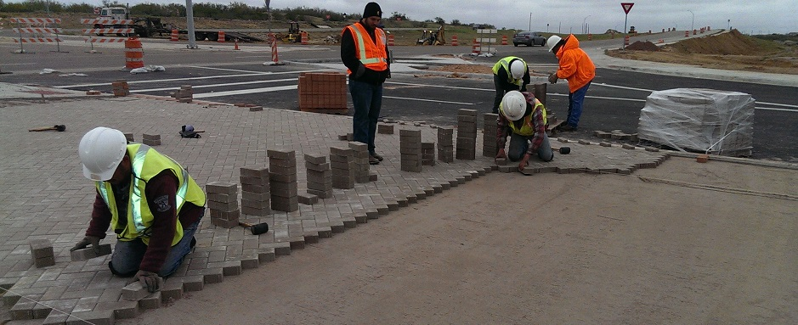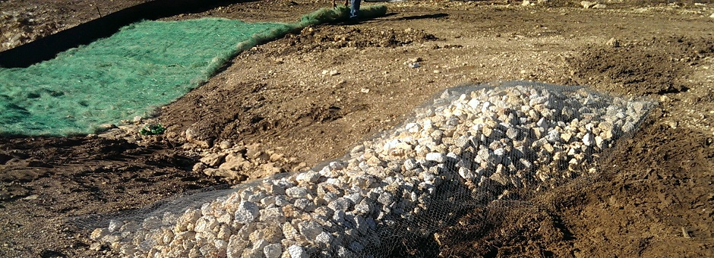

D&S Texas Icon Construction
www.DSTXICON.com
Offices: Austin and Edinburg

Qualified and Experienced TXDOT Contractor
NAICS 237310
Heavy Highway Construction
Erosion Control, Landscaping,
Interlocking Concrete Pavers
(ICPI Certified)
Certified:
TXDOT DBE, TX HUB, MBE
New Project?
Call: (956) 460.1290
D&S Texas Icon Construction, LLC
was established in 2011 by
Channing Santiago (President) and
Mark De Leon (Vice-President).
The company is headquartered in Austin, with another office in Edinburg.
We work from the Central Texas Hill Country to the Rio Grande Valley.
D&S TX Icon is an experienced TXDOT contractor with the staff to complete projects on-time and within budget
to meet state requirements.
Contact Us
Channing Santiago, President
D&S Texas Icon Construction, LLC
PO Box 2720 Edinburg, TX 78540
Phone: (956) 460.1290
Fax: (956) 223.4146
Mark De Leon, Vice President
1521 Sir Thopas Trail Austin, TX 78748
(512) 584.6215

D&S Texas Icon Construction, LLC
PO Box 2720
Edinburg, TX 78540
Recent Municipal and TXDOT Projects
D&S Texas Icon Construction (D&S TX ICON) provides a variety of
professional services for highway construction projects.
City of Laredo: Interlocking Concrete Pavers
TxDOT Williamson County FM 487: Erosion Control | Silt Fence Installation
TxDOT Blanco County US 281: Broadcast Seeding | Erosion Control
TxDOT Webb County SL 20: Spray-On Erosion Control Blankets
TxDOT Nueces County SH 44: Broadcast Seeding | Erosion Control
TxDOT Brooks County US 281: Drill Seeding | Erosion Control Blankets

New Project? Call Today: (956) 460.1290
For more information: www.DSTXIcon.com
Professional Services
Erosion Control | Seeding / Sodding
• Erosion Control Blankets
• Silt Fence
• Biodegradable Logs
• Rock Filter Dams
• Construction Exits
• Rock Gabions
• Seeding | Sodding Native Grasses via:
Broadcast, Drill, Hydromulch
ICPI Certified expertise
Installation of
Interlocking Concrete Pavers
Concrete Flatwork
• Concrete Riprap
• Sidewalks
• Stamped Concrete
• Colored Textured Concrete

Landscaping Services
Roadway and Commercial Landscaping:
• Grasses, Plants and Tree Installation
• Tree Transplanting
• Plant Bed Preparation, Mulching
• Construction of Modular Walls

Our Mission:
We are committed to providing
excellent construction services
for the betterment of the
communities in which we work.

