Experienced, Professional TXDOT Highway Contractor
Erosion Control | Seeding/Sodding | Interlocking Concrete Pavers | Landscaping
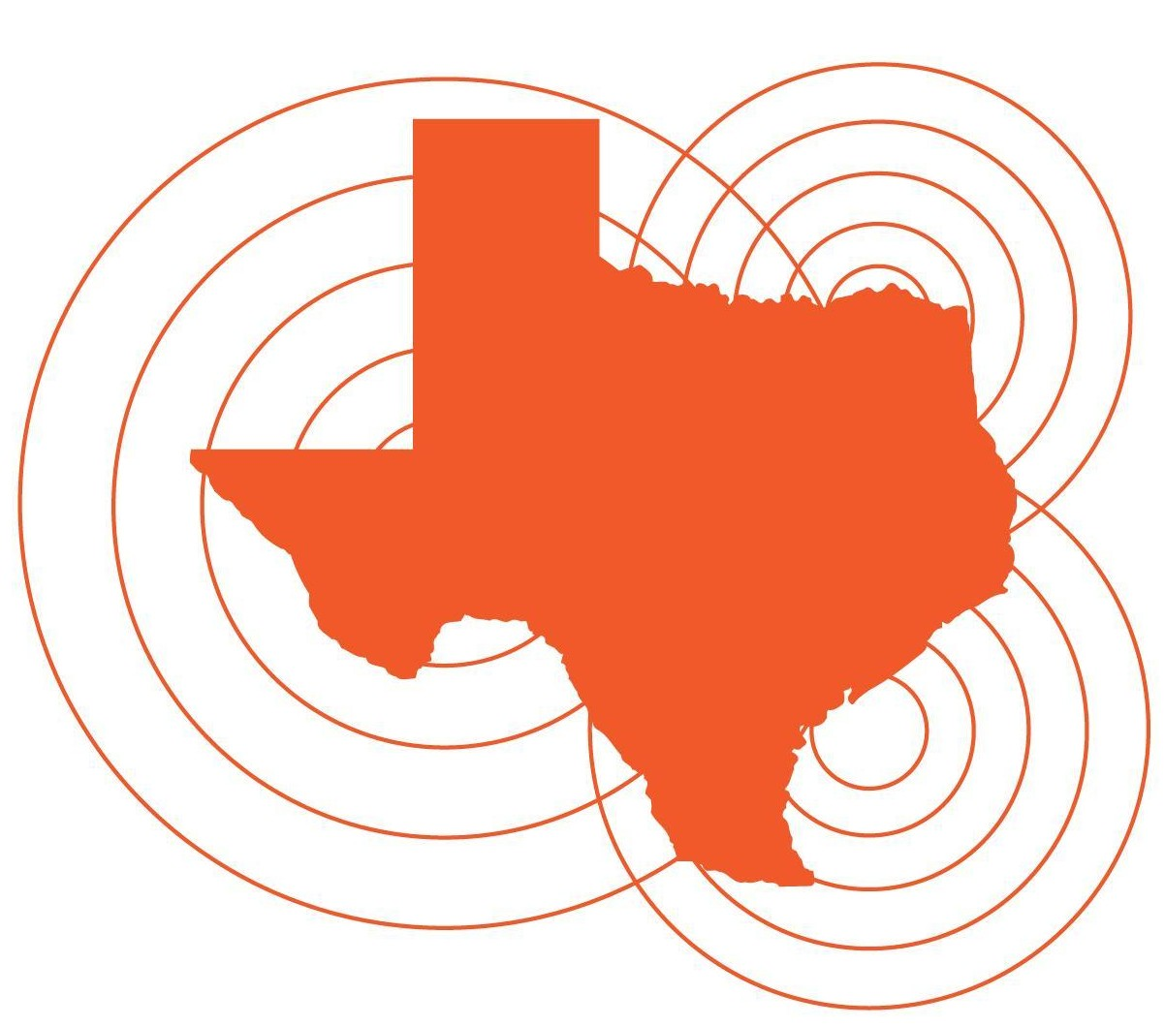
Channing Santiago, President
Email: csantiago@DSTXIcon.com
Mailing Address: PO Box 2720 Edinburg, TX 78540
Edinburg: (956) 460.1290 | Fax: (956) 223.4146

Mark De Leon, Vice President
Email: mdeleon@DSTXIcon.com
Austin Office: (512) 584.6215
Address: 1521 Sir Thopas Trail Austin, TX 78748
NAICS: 237310 Heavy Highway Construction
Certifications: TXDOT DBE, Texas HUB, MBE
Our Mission Statement
D&S Texas Icon Construction is committed to providing excellent construction services for the betterment of the communities in which we work.
D&S TX Icon was established in 2011 by Channing Santiago (President) and Mark De Leon (Vice-President). The company is headquartered in Austin, with another office in Edinburg. We serve commercial clients from the Central Texas Hill Country to the Rio Grande Valley.
Qualified | Certified
D&S TX Icon is a certified small business: TXDOT DBE / TX HUB / Austin MBE. TXDOT prime contractors /State Agencies meet small business participation partnering with D&S TX Icon.
Professional Services
D&S TX Icon provides a variety of services for highway construction projects. We specialize in:
Erosion Control | Seeding / Sodding | Concrete Flatwork | Interlocking Concrete Pavers | Landscaping
Recent Municipal and TxDOT Highway Projects
• City of Laredo: Interlocking Concrete Pavers
• TxDOT, Williamson County FM 487: Erosion Control | Silt Fence Installation
• TxDOT, Blanco County US 281: Broadcast Seeding | Erosion Control
• TxDOT, Webb County SL 20: Spray-On Erosion Control Blankets
• TxDOT, Nueces County SH 44: Broadcast Seeding | Erosion Control
• TxDOT, Brooks County US 281: Drill Seeding | Spray-On Erosion Control Blankets

